**Smart Wireless Water Meter**

## A PROJECT REPORT

***Submitted by***

* **Name:- Nidhi Sharma(21BCS9922)**
* **Name: - Rakesh Saini(21BCS9964)**
* **Name: - Sameer(21BCS9975)**
* **Name: - Aashi Jain(21BCS9979**

***in partial fulfillment for the award of the degree of***

# BACHELOR OF ENGINEERING

**IN**

COMPUTER SCIENCE ENGINEERING



## Chandigarh University

MAY 2022



# BONAFIDE CERTIFICATE

Certified that this project report **“Smart Wireless Water Meter ”** is the bonafide work of **Rakesh Saini, Aashi Jain, Nidhi Sharma, Sameer ”** who carried out the project work under my/our supervision.

**SIGNATURE SIGNATURE**

**Shonak Bansal** **Gaurav Bathla**

**SUPERVISOR**

**Assistant Professor Chandigarh University HEAD OF THE DEPARTMENT**

Submitted for the project viva-voce examination held on

**INTERNAL EXAMINER EXTERNAL EXAMINER**

# ACKNOWLEDGEMENT

We express our deep sense of gratitude to our respected and learned guides, **Dr. Shonak Bansal** for their valuable help and guidance, we are thankful to them for the encouragement they have given us in completing the project.

We are also grateful to our respected HOD Dr. Gaurav Bathla and all other teachers for providing us assistance in various stages during the course of our project.

Finally, we express our gratitude to all other members who are involved either directly or indirectly forth completion of this project.

Signature of all the group members

1. Nidhi Sharma
2. Rakesh Saini
3. Sameer
4. Aashi Jain

**Introduction:**

There is shortage of drinking water and unsustainable stress is being imposed on drinking water sources.

In recent years, demand for water has increased in households. Consumer awareness about the day water consumption is very low. Traditional water meters cannot be used properly on a daily basis and water consumption are calculated once a month.

Our Smart Wireless Water Meter project enables apps to automatically collect usage data, remove manual meter readings, improve efficiency and save costs. It also provides an opportunity to detect leaks and rare uses more effectively than manual methods.

The proposed system contains a Smart Water Meter (Built with Arduino Uno -microcontroller board, Flow Sensor, SD card module, and Wi-Fi Shield), web application

**Key Features:**

* Monitor the flow, distribution and consumption of water.
* Improve access to clean and safe water.
* Improve leak and fraud detection.
* Increase data collection accuracy.
* Enable real-time or frequent access to water consumption information and billing.
* More economical for users.
* Saved water can be supplied to areas suffering from water scarcity.

**Objectives:**

* Capable of implementing the volume based slab system. After reaching each limit the consumer are informed and cautioned through an Alarm.
* Develop an online platform to upload meter reading, calculate customer’s bills, and receive their bill information.
* To estimate household water consumption and pattern by recording accurate readings.
* To analyze water-saving potential for the residential sector.

**Block Diagram:**

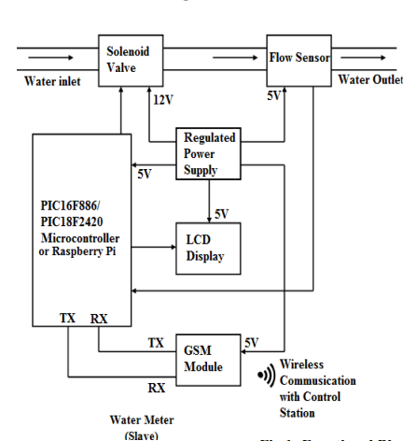

**Result:**

The outcome of this project is a simple Arduino-controlled smart water meter that measures the amount of water consumed by the residential sector. During the operation of the meter, water flows through the flow sensor which is a device that detects and measures water flow through pipes. The water flow follows through the rotor blade. Thus, pulses produce an output frequency that is directly proportional to the volumetric flow rate/total flow rate through the meter.

**Conclusion and Future Scope:**

A smart water meter can solve many of the problems facing existing meters. Although the maximum efficiency of the proposed meter has not been achieved, there is scope for future upgrades and further improvements.

Instead of installing one meter in each house, provisions can be made to allow for different monitoring of water use in each section such as kitchen, bathroom etc. It can then monitor and control the water used. All additional infrastructure created can be automated with high accuracy. By knowing the correct use of water in different parts of the same house, you may know that there is a leak. Leaks or theft if any can be repaired individually, which can be easily repaired.

**References:**

# T Randall, Richard Koech, ‘Smart Water Metering Technology for Water Management in Urban Areas Analysing water consumption patterns to optimise water conservation’ , DOI:[10.21139/wej.2019.001](http://dx.doi.org/10.21139/wej.2019.001).

# Sarala S.M , ‘Smart Water Meter Using Wireless Networking’ , Project Reference NO.: 40S_BE_0108, 2019.